|  |
| --- |
|  |
| Teaching Allocation System |
| User Manual |
|  |
| **QUT Capstone Team Turing** |
| **10/27/2020** |

|  |
| --- |
|  |

Contents

Set-Up 3

Home Page 5

Allocation Page 6

Screen Display Breakdown 7

Add Allocation 7

Edit Allocation 7

Delete Allocation 7

Manage Years 8

Add year 8

Edit Year 8

Delete year 9

Academics Page 10

Add Academic 11

Edit Academic 11

Delete Academic 12

Manage Tags 12

Add Tags to Academic 13

Delete Tags from Academic 13

Manage Years 13

Add year 14

Edit Year 14

Delete year 15

Units Page 16

Add Unit (If already established Unit) 17

Add Unit (If unestablished Unit) 18

Edit Unit 18

Delete Unit 19

Manage Tags 20

Add Tags to Unit 21

Delete Tags from Unit 21

Manage Years 21

Add year 22

Edit Year 22

Delete year 23

Import Page 24

Export Page 25

Trouble Shooting 26

# Set-Up

This section will discuss how to start up the Teaching Allocation System.

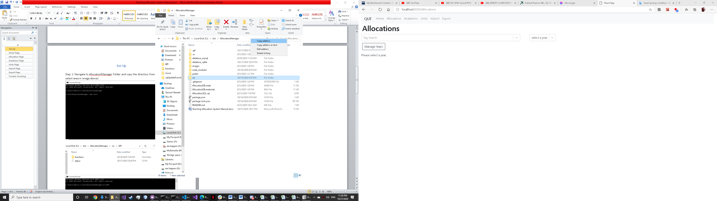

**Step 1:** Navigate to AllocationManager Folder and copy the address by right clicking the path bar. (see selected area in image above)

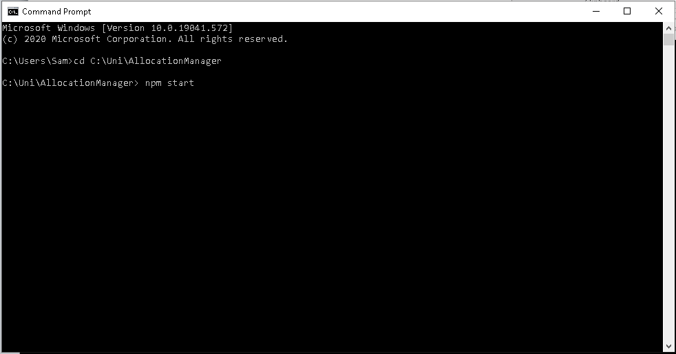

**2.**

**1.**

**Step 2:** Open a Command Prompt window via the windows search bar and enter the command “cd” space your address you just copied by pressing “Ctrl V” and then press enter (see 1.)

**Step 3:** Enter the command “npm start” and press enter (see 2.) If this is the first every start up first enter the command “npm install” and press enter then run “npm start”.

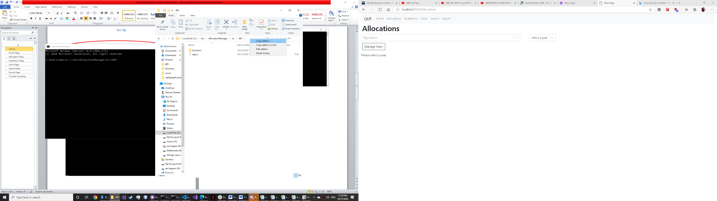

**Step 4:** Navigate to API Folder from the AllocationManger Folder and copy the address by right clicking the path bar. (see selected area in image above)

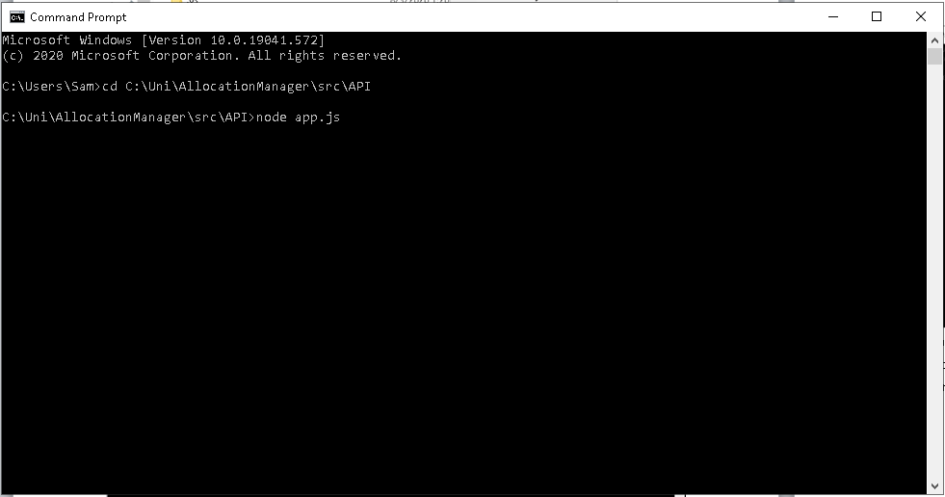

**2.**

**1.**

**Step 5:** Open a Command Prompt window and enter the command “cd” space your address you just copied my pressing “Ctrl V” and then press enter (see 1.)

**Step 6:** Enter the Command “node app.js” and press enter (see 2.)

# Home Page

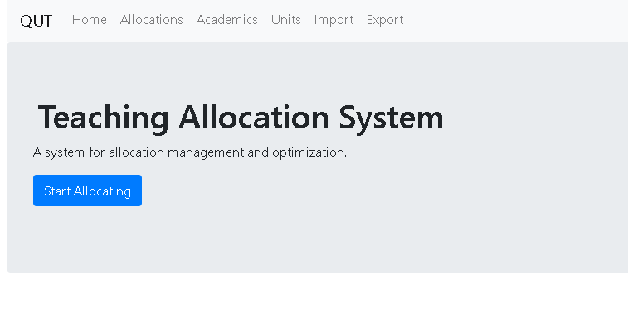**1.** Use this button (Home) to navigate to this page

**7.**

**4.**

**5.**

**6.**

**3.**

**2..**

**1.**

**2.** Use this button (Allocations) to navigate to the Allocations page (same function as 7.)

**3.** Use this button (Academics) to navigate to the Academics page

**4.** Use this button (Units) to navigate to the Units page

**5.** Use this button (Import) to navigate to the Import page

**6.** Use this button (Export) to navigate to the Export page

**7.** Use this button (Start Allocating) to navigate to the Allocations page (same function as 2.)

# Allocation Page

This section goes over the elements of the allocation page as well as how to operate it.

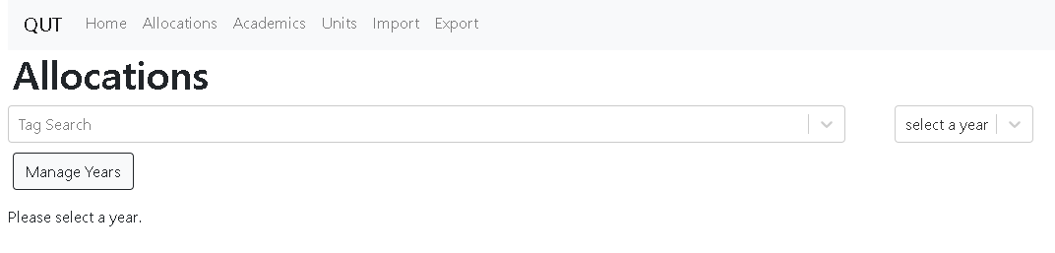

**Opening Page:** To view the allocation data please select the year you wish to view by selecting a year in the drop down (see above image)

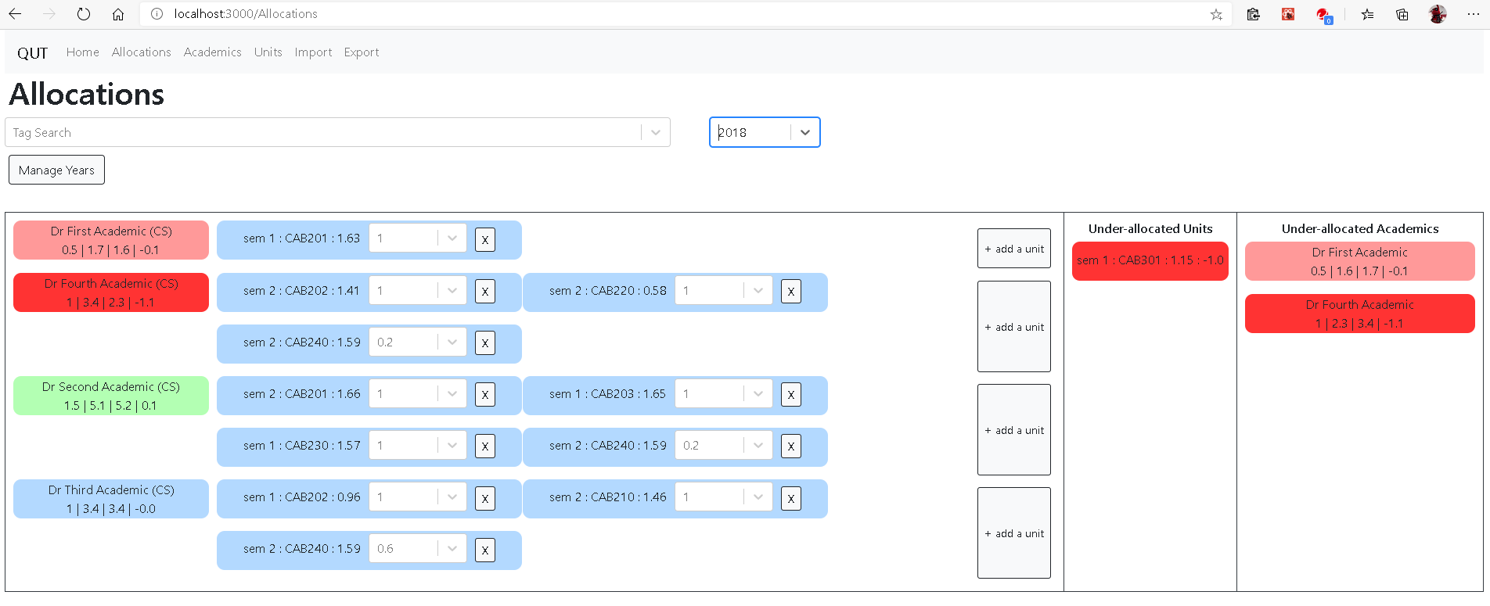

**3.**

**2.**

**1.**

**Viewing Data:** To view less or more data in the main display, Tags can be entered and removed from the tag search bar (see red circle in image above)

**Main Display:** The Main Display is where allocation data is displayed as a list with the academics on the left and the units they have been allocated to on their right (See 1.). Meaning of colors** Green is used whenever a unit or academic is over allocated, going from lighter to darker depending on how much they are over allocated. Blue is used whenever it is not over or under allocated. Red is used whenever an academic or unit is under allocated, going from lighter to darker depending on how much they are under allocated.

**Under Allocated Units Column:** The Under Allocated Units Column is used to display units that have not been allocated fully (See 2.). Meaning of colors** Red is used whenever an unit is under allocated, going from lighter to darker depending on how much they are under allocated.

**Under Allocated Academics Column:** The Under Allocated Academics Column is used to display academics that have not been fully allocated (See 3.). Meaning of colors** Red is used whenever an academic is under allocated, going from lighter to darker depending on how much they are under allocated.

## Screen Display Breakdown



**Allocation Card:** This card displays the semester, Unit Code and the Unit Load as well as the Allocation Amount within the drop down box (from left to right in above image)

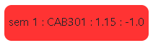

**Under Allocated Unit:** This card is displayed in the “Under Allocated Units” column. It displays the semester, Unit Code, Unit Load and Load Error (from left to right in above image). Load Error shows the amount left to be allocated



**Under Allocated Academic:** This card is displayed in the “Under Allocated Academics” column as well as the main display. It displays the name of the academic as well as their Load | Unit Load | Actual Load | Load Error (from left to right in above image)

## Add Allocation

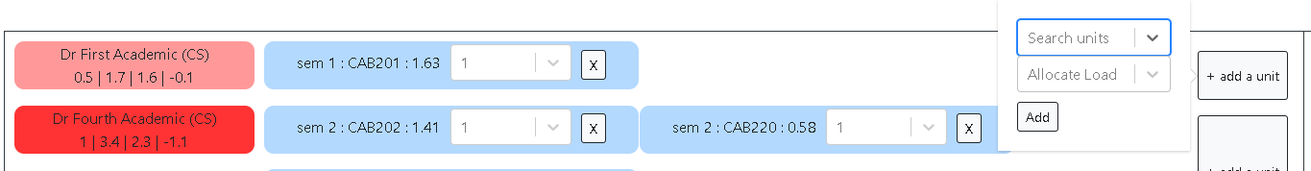

**2.**

**3..**

**4..**

**1.**

**Step 1:** click the “add unit” button on the far right side of the main display in line with the academic you wish to assign to (see 1.)

**Step 2:** Select the unit you wish to allocated (see 2.) and the amount of the unit you wish to allocate (see 3.), then press “Add” (see 4.)

## Edit Allocation



**1.**

**Step 1:** To edit the allocation amount change the drop down to the amount you wish to allocate (see 1.)

## Delete Allocation

**1.**



**Step 1:** To delete the allocation click the X (see 1.) and then select yes in the popup.

## Manage Years

This section will go over the “Manage Years” button.

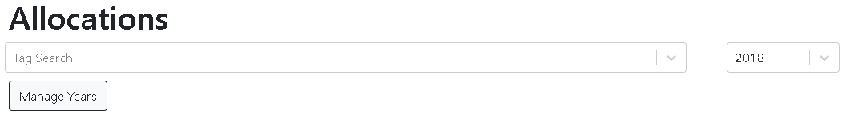

**Enter pop-up:** To see the ““Manage Years” popup click the “Manage Years” button (see image above)

### Add year

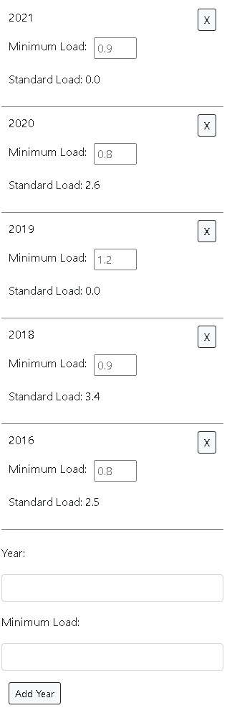

**1.**

**2.**

**3.**

**Step 1:** Enter the year into the first input box (see 1.), then enter the minimum load into the second input box (see 2.), at last click “Add year” (see 3.)

### Edit Year



**1.**

**Step 1:** Enter the new Minimum Load into the input box on the year you wish to edit (see 1.). Then click off the input box.

### Delete year



**1.**

**Step 1:** Click the X (see 1.) and then select “Yes” in the popup.

# Academics Page

This section goes over the elements of the allocation page as well as how to operate it.

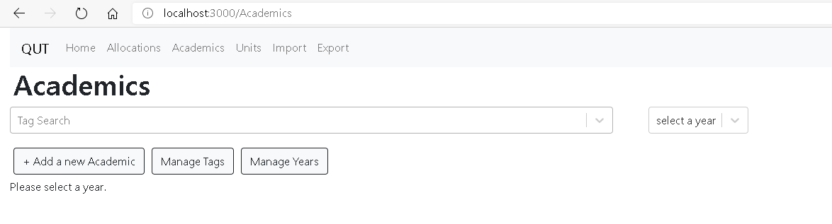

**Opening Page:** To view the academic data please select the year you wish to view by selecting a year in the drop down (see above image)

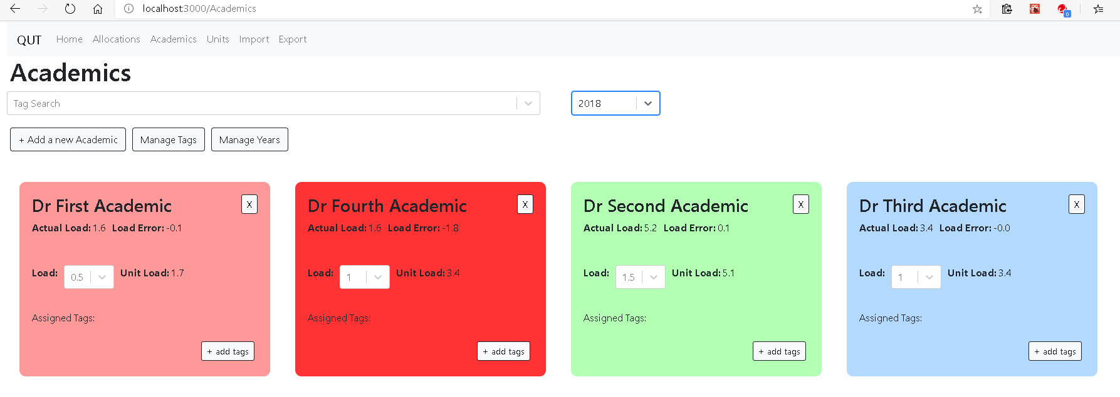

**Viewing Data:** To view less or more data, Tags can be entered and removed from the tag search bar (see red circle in image above)

## Add Academic

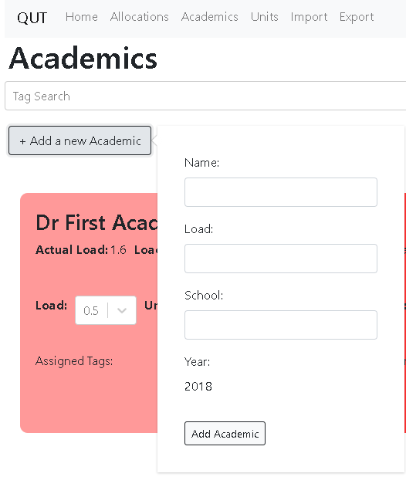

**5.**

**4.**

**3.**

**2.**

**1.**

**Step 1:** To add an academic firstly click the “+Add a new Academic” button (see 1.)

**Step 2:** Enter the academics name (see 2.), Load (see 3.) and School (see 4.)

**Step 3:** Click the “Add Academic” button (see 5.)

## Edit Academic

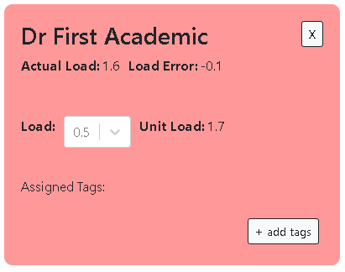

**1.**

**Step 1:** Change drop down box to desired load (see 1.) then click off the drop down box.

## Delete Academic



**1.**

**Step 1:** Click the X button (see 1.)

## Manage Tags

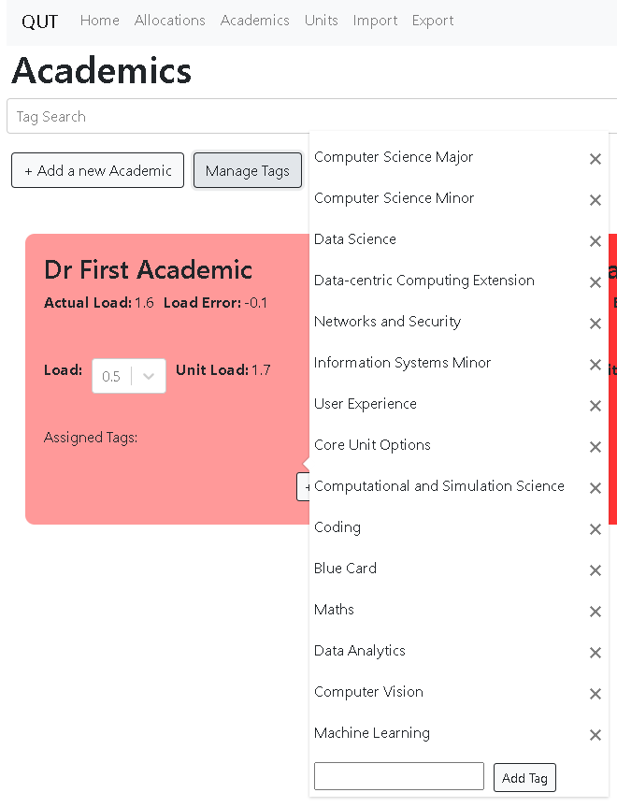

**2.**

**1.**

**View all Tags:** Click the“Manage Tags” button (see red circle in the image above)

**Add Tag to catalog:** Enter Tag into the input box (see 1.) then click the “Add Tag” button (see 2.)

### Add Tags to Academic

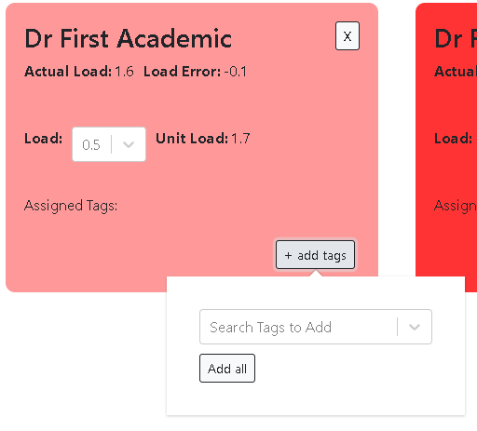

**3.**

**2.**

**1.**

**Step 1:** Click “+ add tags” button (see 1.)

**Step 2:** Open drop down and select the tags you wish to assign (see 2.) then click “Add all” button (see 3.)

### Delete Tags from Academic

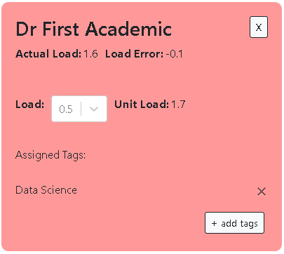

**1.**

**Step 1:** Click X button in line with the tag you wish to remove (see 1.)

## Manage Years

This section will go over the “Manage Years” button.



**Enter pop-up:** To see the ““Manage Years” popup click the “Manage Years” button (see image above)

### Add year



**1.**

**2.**

**3.**

**Step 1:** Enter the year into the first input box (see 1.), then enter the minimum load into the second input box (see 2.), at last click “Add year” (see 3.)

### Edit Year



**1.**

**Step 1:** Enter the new Minimum Load into the input box on the year you wish to edit (see 1.). Then click off the input box.

### Delete year



**1.**

**Step 1:** Click the X (see 1.) and then select “Yes” in the popup.

# Units Page

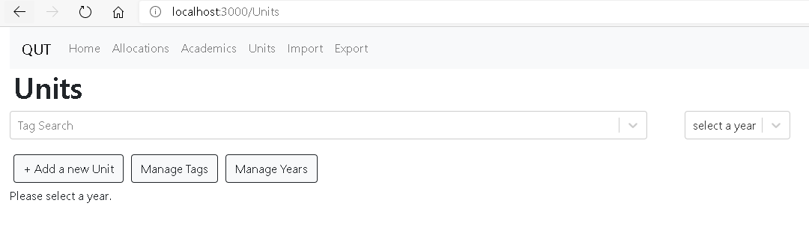

**Opening Page:** To view the Unit data please select the year you wish to view by selecting a year in the drop down (see above image)

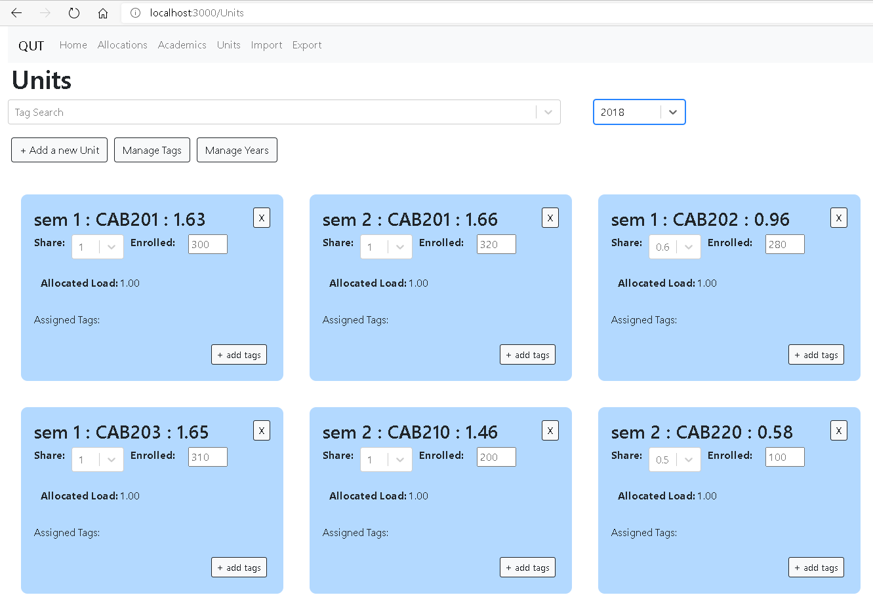

**Viewing Data:** To view less or more data, Tags can be entered and removed from the tag search bar (see red circle in image above)

## Add Unit (If already established Unit)

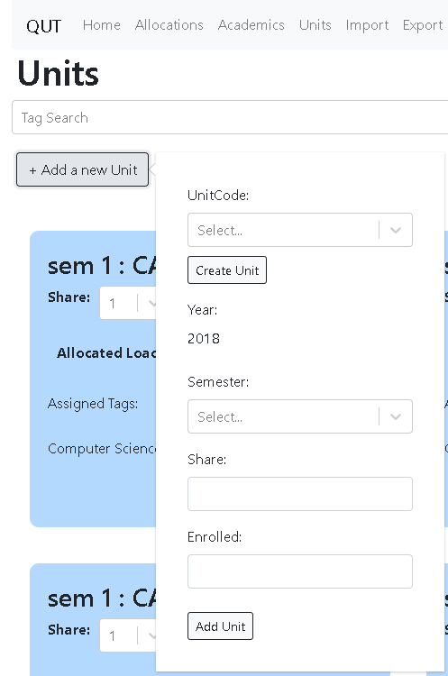

**1.**

**6.**

**5.**

**4.**

**3.**

**2.**

**Step 1:** Click the “+Add a new Unit” button (see 1.)

**Step 2:** Select the Unit Code (see 2.), Semester (see 3.), Share (see 3.) and number of students enrolled (see 4.)

**Step 3:** Click the “Add Unit” button (see 6.)

## Add Unit (If unestablished Unit)

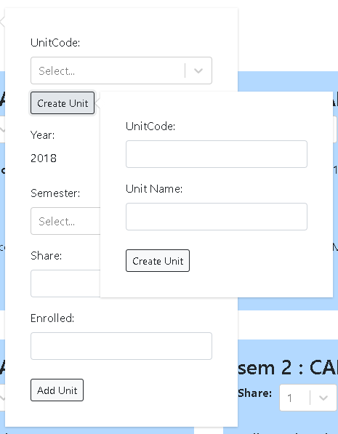

**3.**

**4.**

**2.**

**1.**

**Step 1:** Click the “Create Unit” button (see 1.)

**Step 2:** Enter the Unit Code (see 2.) and Unit Name (see 3.)

**Step 3:** Click the “Create Unit” button (see 4.)

**Step 4:** Refer to “Add Unit (if already established Unit)” Section within this chapter

## Edit Unit

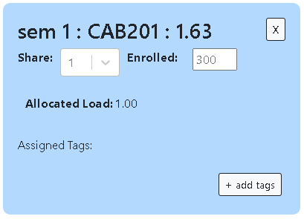

**2.**

**1.**

**Step 1:** Change drop down box to desired share (see 1.) and the number of students enrolled (see 2.) then click off the drop down box.

## Delete Unit



**1.**

**Step 1:** Click the X button (see 1.)

## Manage Tags

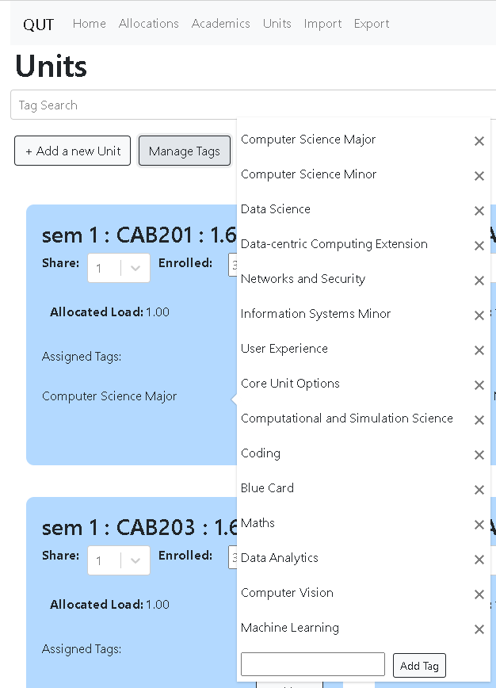

**2.**

**1.**

**View all Tags:** Click the“Manage Tags” button (see red circle in the image above)

**Add Tag to catalog:** Enter Tag into the input box (see 1.) then click the “Add Tag” button (see 2.)

### Add Tags to Unit

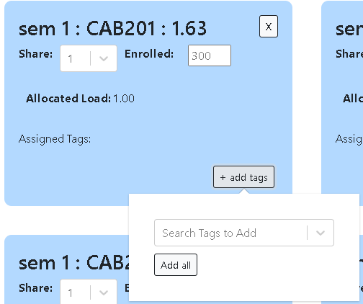

**1.**

**3.**

**2.**

**Step 1:** Click “+ add tags” button (see 1.)

**Step 2:** Open drop down and select the tags you wish to assign (see 2.) then click “Add all” button (see 3.)

### Delete Tags from Unit

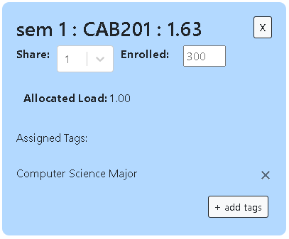

**1.**

**Step 1:** Click X button in line with the tag you wish to remove (see 1.)

## Manage Years

This section will go over the “Manage Years” button.

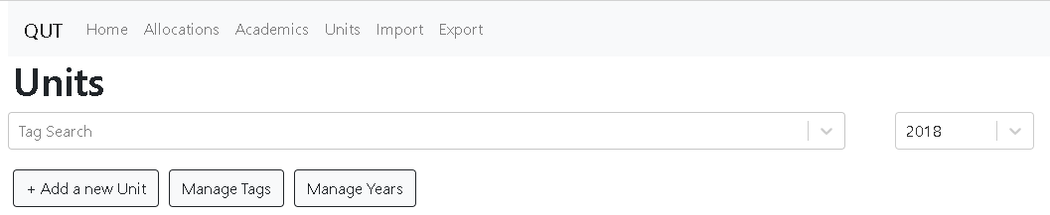

**Enter pop-up:** To see the ““Manage Years” popup click the “Manage Years” button (see image above)

### Add year



**3.**

**1.**

**2.**

**Step 1:** Enter the year into the first input box (see 1.), then enter the minimum load into the second input box (see 2.), at last click “Add year” (see 3.)

### Edit Year



**1.**

**Step 1:** Enter the new Minimum Load into the input box on the year you wish to edit (see 1.). Then click off the input box.

### Delete year



**1.**

**Step 1:** Click the X (see 1.) and then select “Yes” in the popup.

# Import Page

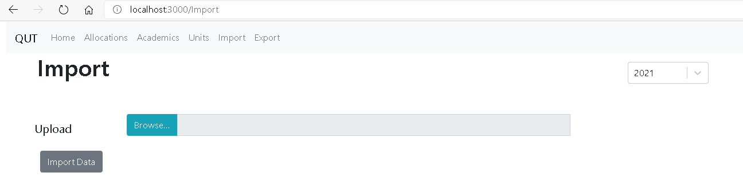

**2.**

**3.**

**1.**

**Importing a page:** To import a page first select the year to put the data in (see 1.). Then click “Browse” and select the file you wish to import (see 2.) .Finally, click the “Import Data” button (see 3.). This process can take a minute to complete.

# Export Page

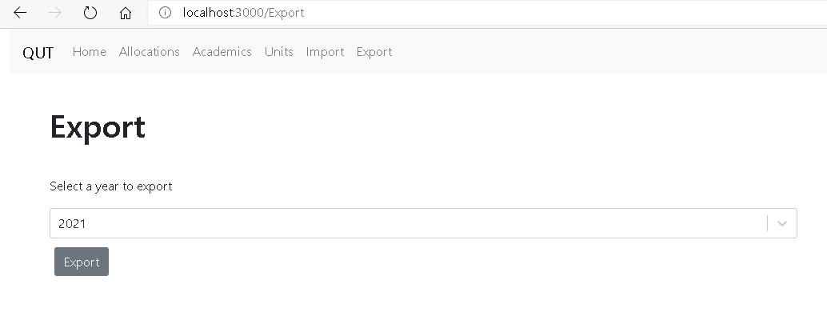

**2.**

**1.**

**Exporting a page:** To export a year select the year that is to be exported (see 1.). Then click the “Export” button (see 2.). A download should automatically begin.

# Trouble Shooting

|  |  |
| --- | --- |
| Unable to select years to view data | Make sure backend has been started (this is step 4 to 6 of the set-up) |
| Data failed to update | Refresh the page, otherwise re-enter the data and check again. If failing for the second time restart the backend (this is step 4 to 6 of the set-up) |